1. Enter the temperature in Celsius and convert that into Fahrenheit.

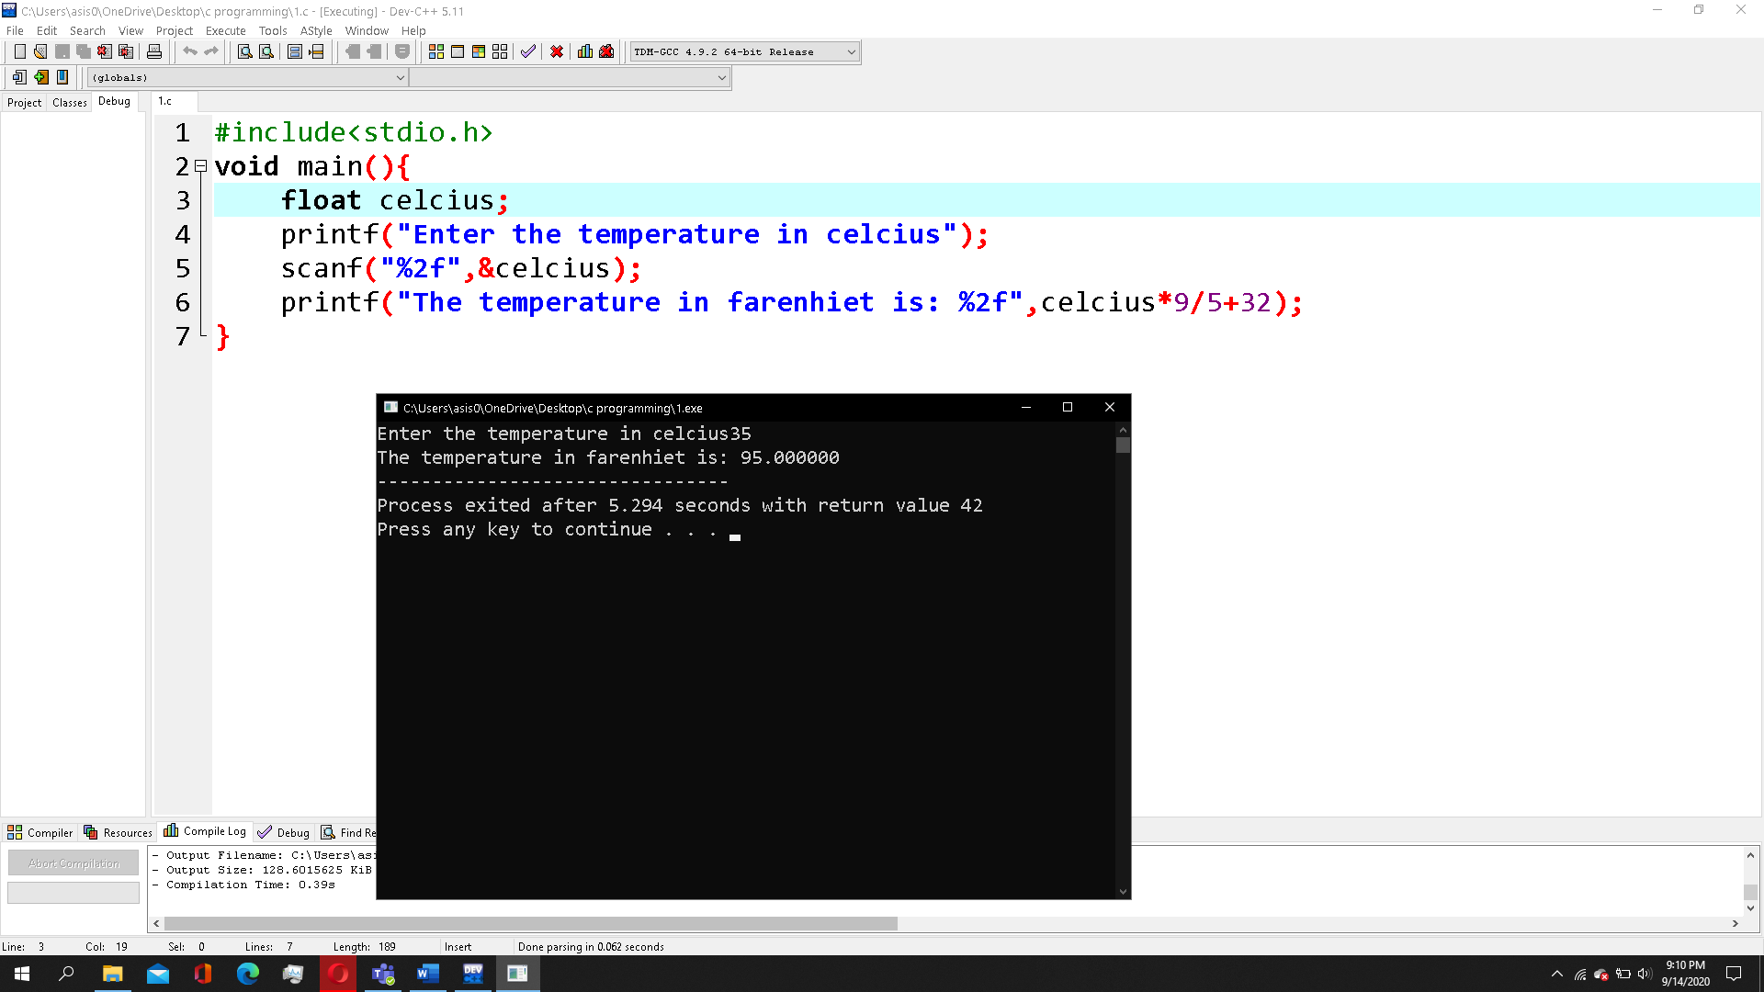

1. Accept the radius of the circle and calculate the area and perimeter of the circle.

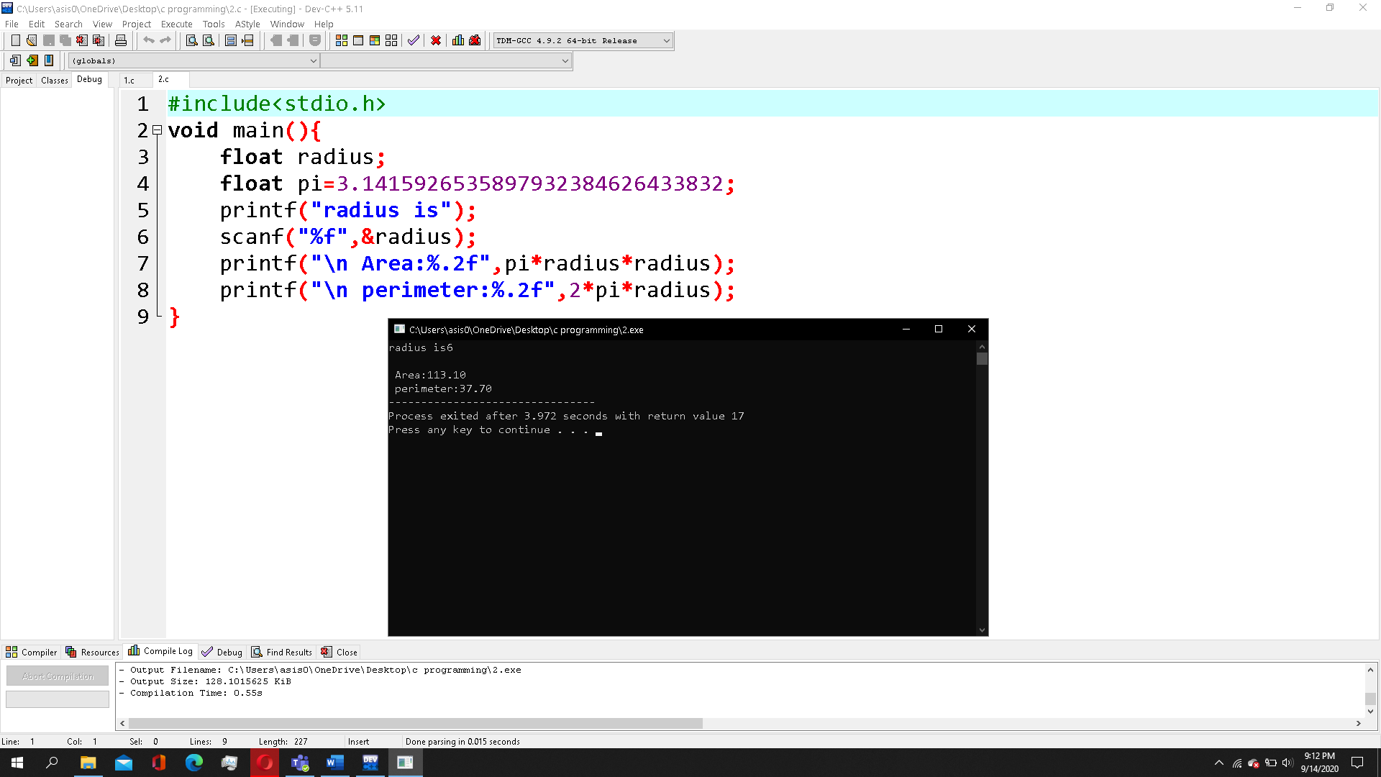

1. write a program to accept the number in decimal and print the number in octal and hexadecimal.

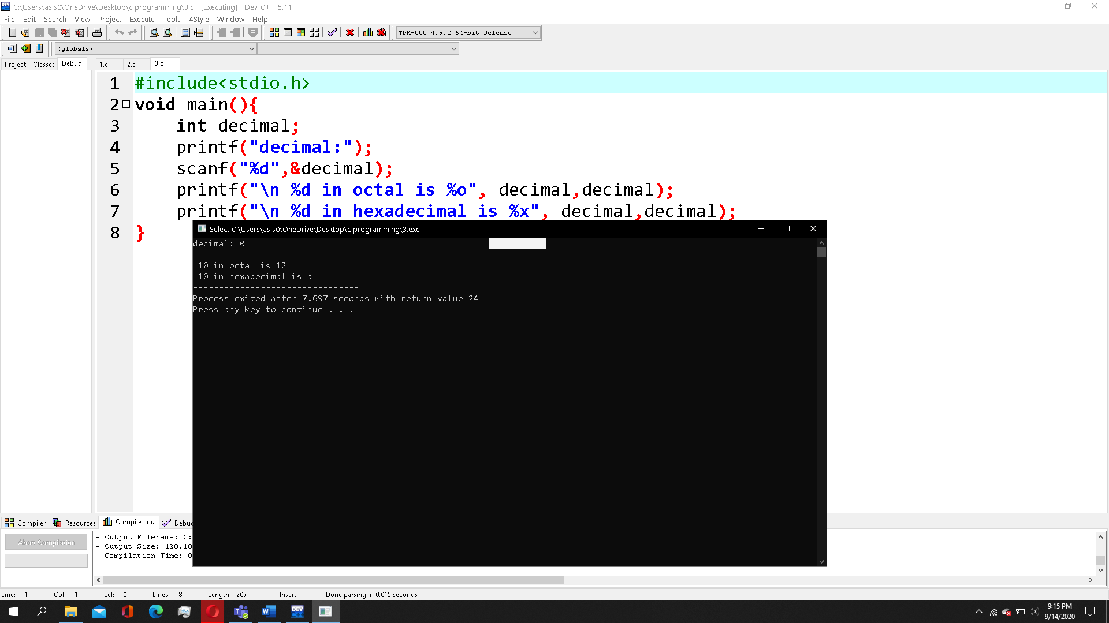

1. Accept any five-digit number and print the value of remainder after dividing by 3

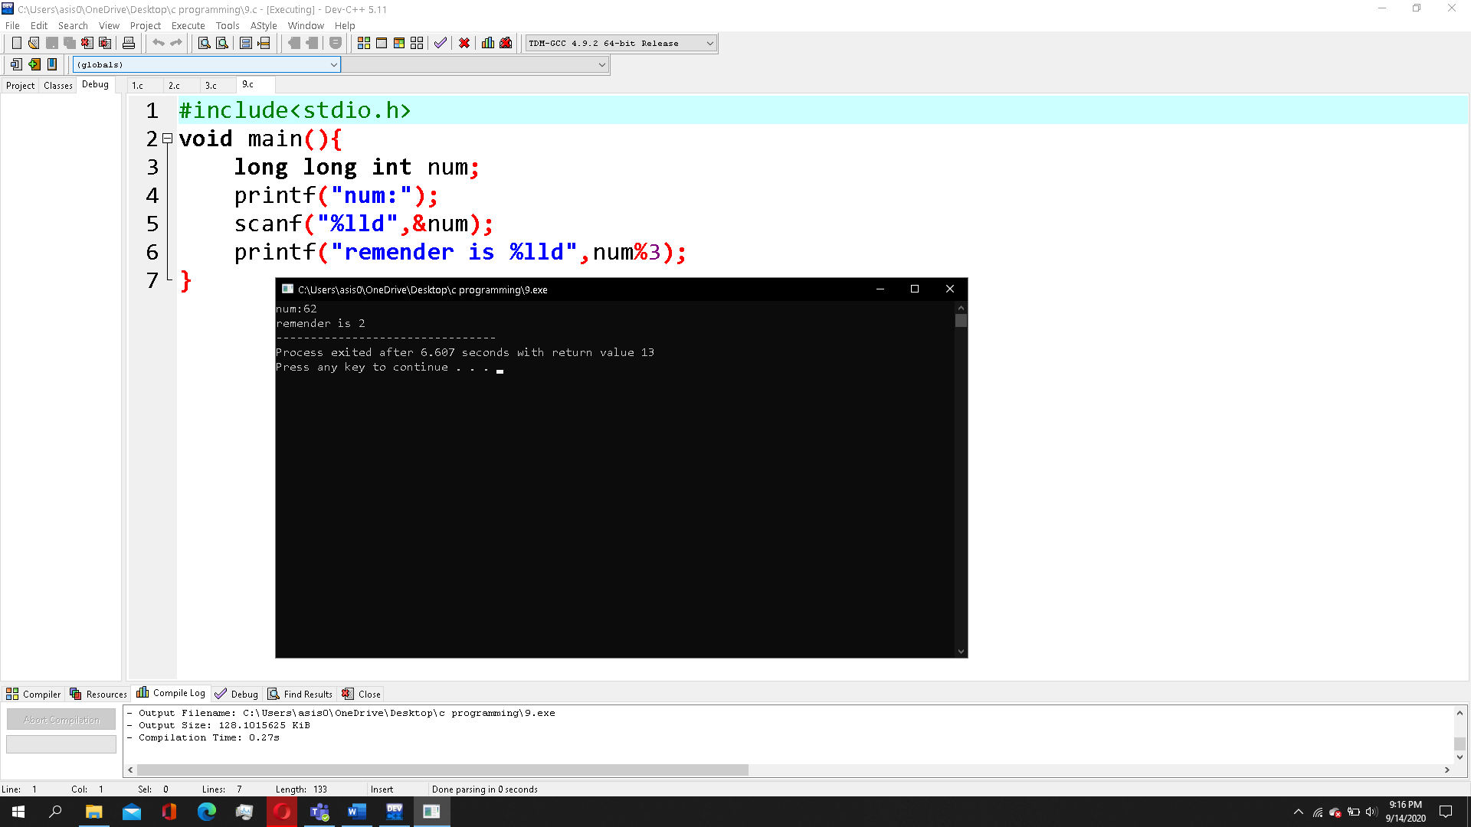

1. Write a program to accept the principle, rate and number of years and find out the simple interest.

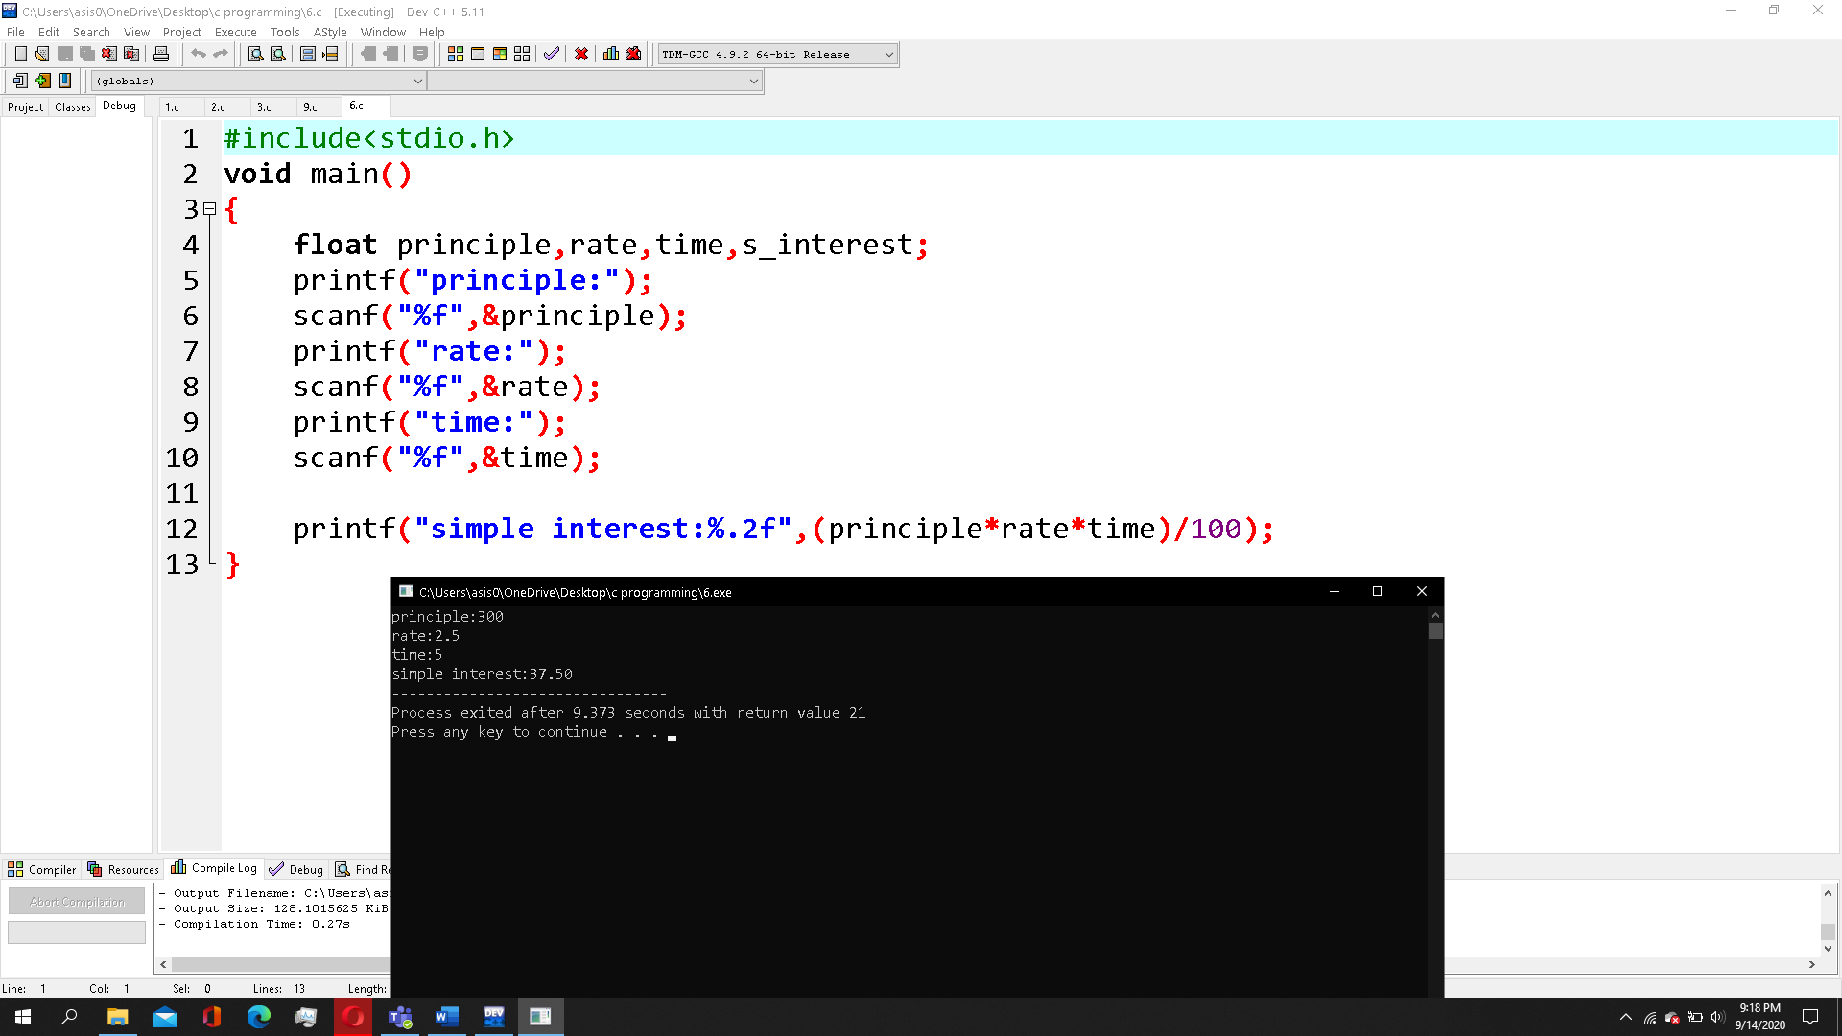

1. Accept any two numbers, if the first number is greater than second then print the sum of these two numbers, otherwise print their difference. write this program using ternary operator.

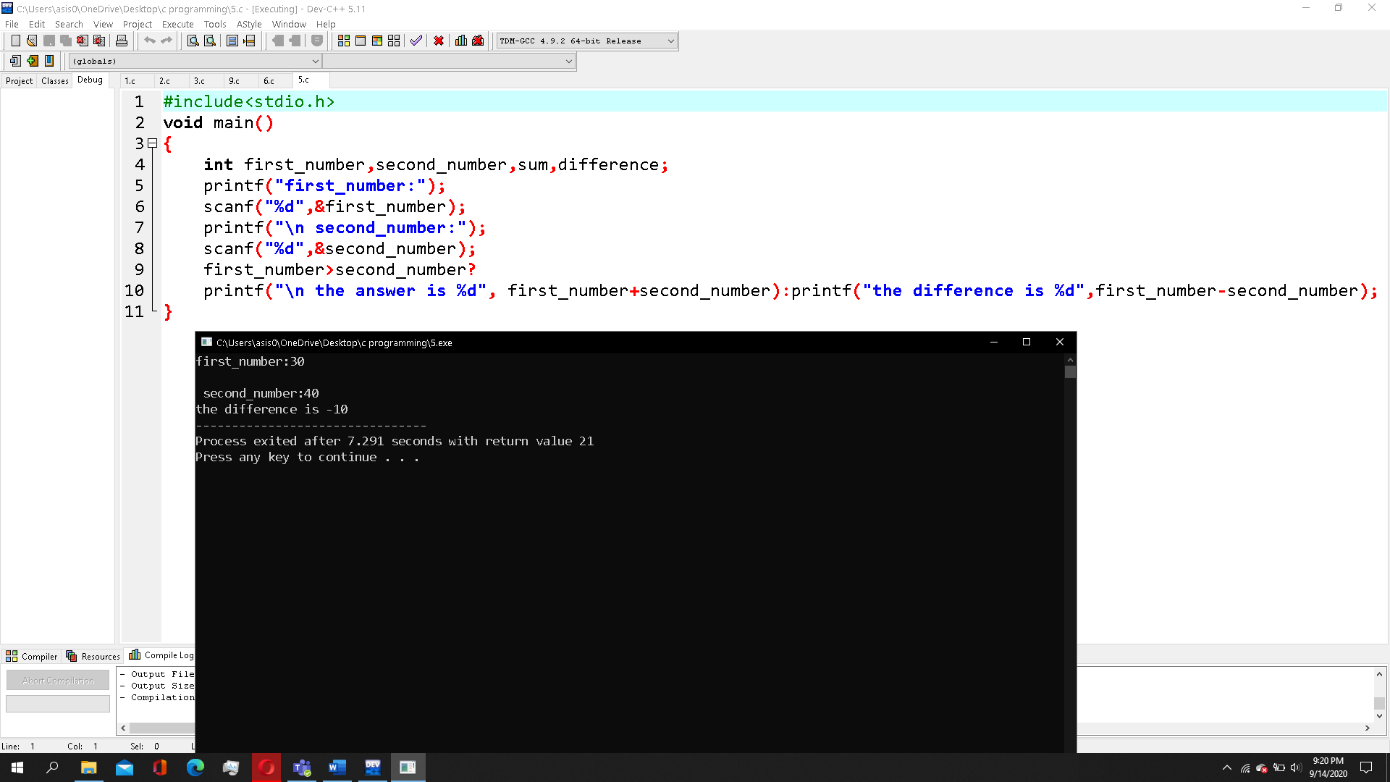

1. Accepts marks in five subject and calculate the total percentage marks.

